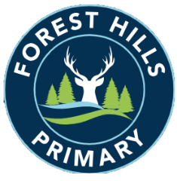
Forest Hills Primary School
Long Term Planning - Science - 2023-24
Cycle A
Subject | Autumn |  | Spring |  | Summer
KS1 | The Human Body | Animals and their Needs | Seasons and Weather | Taking Care of the Earth | Plants | Materials and Magnets
LKS2 | The Human Body | Cycles in Nature | Light | Plants | Rocks | Forces and Magnets
UKS2 | The Human Body | Materials | Living Things | Forces | Astronomy | Meteorology

Long Term Planning - Science - 2024-25
Cycle B
Subject | Autumn |  | Spring |  | Summer
KS1 | The Human Body | Animals and their Needs | Astronomy | Materials and Matter | Plants | Electricity
LKS2 | The Human Body | Classification of Plants and Animals | Ecology | Sound | States of Matter and the Water Cycle | Electricity
UKS2 | The Human Body | Classification of Living Things | Electricity | Light | Reproduction | Evolution

