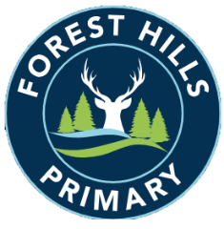
Forest Hills Primary School
Long Term Planning – Design and Technology - 2023-24
Cycle A
Subject | Autumn |  | Spring |  | Summer
KS1 | Dips and Vegetables | Jam Tarts / Mince Pies |  | Animal Sock Puppets |  | Vehicles
LKS2 | Bread and Butter | Pasta |  | Pop-up Books |  | Key Rings / Decorations
UKS2 | Honey Cake | Pitta Bread |  | Cams Toys |  | Bags

Long Term Planning – Design and Technology - 2024-25
Cycle B
Subject | Autumn |  | Spring |  | Summer
KS1 | Pizza | Gingerbread |  | Pencil Cases |  | Moving Pictures
LKS2 | Apple Crumble | Ratatouille and Couscous |  | Cushions |  | Moving Miniature Playgrounds
UKS2 | Mezze | Water Walls |  | Electrical Toys |  | Upcycling Fashion

